CONTENTS | Page
Normal Labour | 2
Shock | 7
Obstructed Labour | 9
Pre-eclampsia & Eclampsia | 10
Obstetric Emergencies | 18
Sepsis | 28
Post-Partum Haemorrhage | 35
Care of the Newborn | 43
Answers | 48

NORMAL LABOUR
Objectives:
- Understand normality in the first stage of labour
- Understand normality in the second stage of labour
- Understand the different ways of managing the third stage of labour
- Recognise a labour that is not normal

We define normal birth as: spontaneous in onset, low-risk at the start of labour and remaining so throughout labour and delivery. The infant is born spontaneously in the vertex position between 37 and 42 completed weeks of pregnancy. After birth mother and infant are in good condition. However, as the labour and delivery of many high-risk pregnant women have a normal course, a number of the recommendations in this paper also apply to the care of these women. (WHO: Normal birth: A practical guide)

Risk assessment is not a once-only measure, but a procedure continuing throughout pregnancy and labour. At any moment early complications may become apparent and may induce the decision to refer the woman to a higher level of care.

Key points for good care during normal labour and delivery

- Presence of birth partner or companion. Supportive care during labour is the most important thing to help the woman tolerate labour pains and facilitate the progress of labour.
- Privacy ensured.
- Good communication and building trust with staff.
- Encourage walking around and changing positions frequently.
- Encourage intake of food and drinks.
- Monitor maternal and fetal wellbeing using the partograph.
- Allow the woman to adopt her position of choice for delivery, for example squatting, lying down, on all fours, upright.

Care that is of no benefit and should be abandoned:
× Routine shaving of the vulval area.
× Giving an enema.
× Routinely performing an episiotomy for delivery.
× Fundal pressure

Normal labour and delivery

Progress in the first stage of labour
- Regular contractions of progressively increasing frequency and duration to three contractions in 10 minutes, each lasting 40 seconds or more.
- Rate of cervical dilatation at least 1 cm/hour during the active phase of labour.
- Cervix well applied to the presenting part.

Progress in the second stage of labour
- Steady descent of the baby through the birth canal.
- Onset of expulsive (pushing) phase.
- Once the cervix is fully dilated and the woman is in the expulsive (pushing) phase of the second stage, encourage the woman to assume the position she prefers and encourage her to push.

Delivery of the head
- Ask the woman to pant or give only small pushes with contractions as the baby’s head delivers.
- To control the birth of the head, ensure head delivers at the end of a contraction.
- Continue to gently support the perineum as the baby’s head delivers.

Completion of delivery
- Allow the baby’s head to turn spontaneously.
- After the head turns, place a hand on each side of the baby’s head. Tell the woman to push gently with the next contraction.
- Reduce tears by delivering one shoulder at a time. Move the baby’s head posteriorly to deliver the anterior shoulder.
- Lift the baby’s head anteriorly to deliver the shoulder that is posterior.
- Support the rest of the baby’s body with one hand as it slides out.
- Most babies begin crying or breathing spontaneously.
- Place the baby on the mother’s chest. Thoroughly dry the baby, wipe the eyes and assess the baby’s breathing.
- Clamp and cut the cord if appropriate (this can be delayed).
- Ensure that the baby is kept warm, in skin to skin contact. Wrap the baby in a soft, dry cloth, cover with a blanket and ensure the head is covered to prevent heat loss.
- Palpate the abdomen to rule out the presence of an additional baby and proceed to manage the third stage.

Third stage of labour:
The third stage of labour is the most dangerous time, because of the risk of bleeding which can be life-threatening.
The active management of the third stage must be carried out correctly; otherwise serious complications may occur such as haemorrhage and/or inversion of the uterus.

Active management:
- An oxytocic drug (such as Misoprostol PO) is given after delivery of the baby and immediately after the midwife has palpated the uterus to check that there is not a multiple pregnancy.

- The cord is clamped and cut.

- When the uterus is well contracted it will feel very hard. This should occur 2–3 minutes after the administration of the oxytocic. Then controlled cord traction is used: the lateral surface of one hand is placed firmly over the lower segment of the contracted uterus and counter traction is applied while the cord is gently pulled with the other hand until the placenta and membranes are delivered.

- Steady, sustained cord traction is applied following the curve of the birth canal; this means that at first traction is in a downward direction, then horizontally and finally, when the placenta is visible in the vagina, in an upward direction. If controlled cord traction fails on the first attempt after a minute or two, the midwife should stop traction and wait for the uterus to contract again before a second attempt. As the placenta is delivered, it should be received with both hands at the vulva to prevent the membranes tearing and some being left behind.

Physiological management:

- No oxytocics are used before delivery of the placenta.

- Signs of placental separation are awaited (up to 20 minutes). The signs of placental separation are:
- The uterus becomes very hard, round, mobile and rises in the abdomen
- the cord lengthens
- There may be a little vaginal blood loss.

- Delivery of the placenta is by gravity and maternal effort.

- Cradle the placenta by both hands as it emerges from the vagina. If the placenta fails to deliver, check that the bladder is empty and, if not, ask the woman to pass urine, and then try again to deliver the placenta with the next uterine contraction.

- The cord is clamped after delivery of the placenta (or sometimes when the pulsations have ceased), unless there is a need to clamp and cut the cord for neonatal reasons.

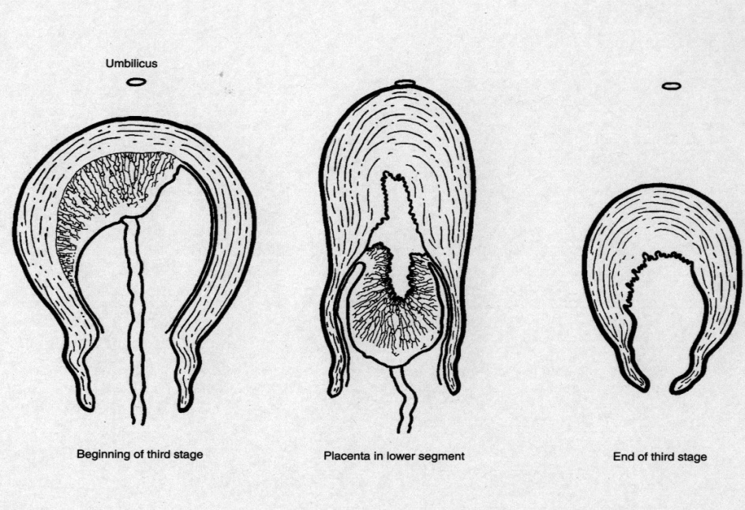
Fundal height relative to the umbilicus during third stage

Postpartum care for the woman

- Measure temperature 4-6 hourly or at least once before discharge if women discharged within 8 hours.
- Measure BP and pulse daily / more frequently if BP raised antenatally
- Check vaginal loss 4-6 hourly.
- Check fundal height and contraction daily – uterus should be firm
- Give regular pain relief as required.

Questions

- Label the drawing:
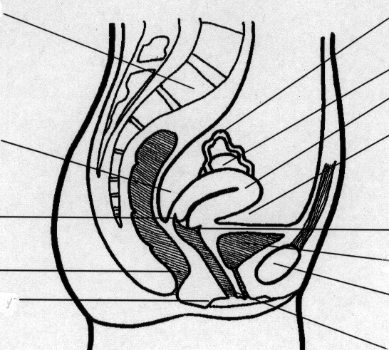

- Why does emptying the bladder improve progress in the first, second and third stages of labour?

- Why should a woman be encouraged to pant as the baby’s head is delivering?

- Why should controlled cord traction not be performed when no oxytocic drugs have been given?

Shock
Objectives
- To recognise shock
- To understand the response to a woman in shock
- To grade levels of unconsciousness
The two main causes of shock in pregnancy are haemorrhage and sepsis.
Shock is a life threatening condition that requires immediate and intensive treatment.
Shock means that there is inadequate perfusion of organs and cells with oxygenated blood.

Recognising shock
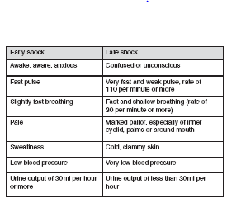
Patients with a reduced level of consciousness
A rapid assessment of conscious level is made using A V P U
Is the patient alert, responding to voice, responding to pain or are they unconscious?
A decrease in the level of consciousness is the marker of insult to the brain (lack of oxygen). The more deeply the patient is (or becomes) unconscious, the more serious the insult.
Lack of oxygen to the brain results from either reduced blood flow (such as hypovolaemia) or reduced oxygen (caused, for example, by reduced breathing, convulsions, sepsis or anaemia).
Call for help
If patient is not breathing then:
- Turn her on her back and place a wedge under the right side of her abdomen to relieve aortocaval compression.
- A: Check airway, remove any obvious obstructions from mouth.
- Perform a head tilt if necessary to ensure airway is patent.
- B: Assess breathing: Look for chest movements; listen for breath sounds; feel for movement of air.
- If she is not breathing assist ventilation.
- C: If she is not breathing in the presence of an open airway, take this as an absence of circulation.
- D: Asses A V P U.
- E: Eclampsia is the most common cause of unconsciousness. Remember, eclampsia can occur before, during or after delivery.
- F:Check for signs of haemorrhage and treat appropriately.
- G: Consider infection: sepsis, malaria.

OBSTRUCTED LABOUR
Objectives:
- To recognise the signs of obstructed labour.
- To be able to respond effectively to a woman who is in obstructed labour.

Labour is considered to be prolonged if a woman is in labour for more than 12 hours without delivery.
Failure to progress in labour may be because of problems with:
- Powers: Inadequate contractions, dysfunctional labour.
- Passage: Pelvis too small for the baby to pass through. Cephalopelvic disproportion.
- Passenger: Malposition or baby too large.

First stage of labour
Findings suggestive of unsatisfactory progress
- Irregular and infrequent contractions after the latent phase and/or
- Cervical dilatation slower than 1 cm/hour and/or
- Cervix poorly applied to the presenting part.
Management
- Ensure use of partograph.
- Encourage mobilisation and hydration.
- Artificial rupture of membranes (ARM).
- Augmentation using oxytocic drugs.
- Reassess by vaginal examination 2 hours after a good contraction pattern with strong contractions has been established.
- Monitor fetal heart more frequently if there is delay.
- If no progress between examinations, deliver by caesarean section.

Second stage of labour
Findings suggestive of unsatisfactory progress
- Lack of descent of fetus through birth canal.
- Failure of expulsion.
Management
- Ensure bladder is empty.
- Allow spontaneous pushing if cervix fully dilated.
- Encourage change of maternal position/mobility.
- If malpresentation and obvious obstruction have been excluded and contractions are inadequate consider augmentation.
- If the fetal head is not more than 2/5 palpable above the symphysis pubis or the fetal head is at the spines or lower, deliver by vacuum extraction.
- If the fetal head is more than 2/5 palpable or the fetal head is above -2 above the ischial spines, deliver by caesarean section.
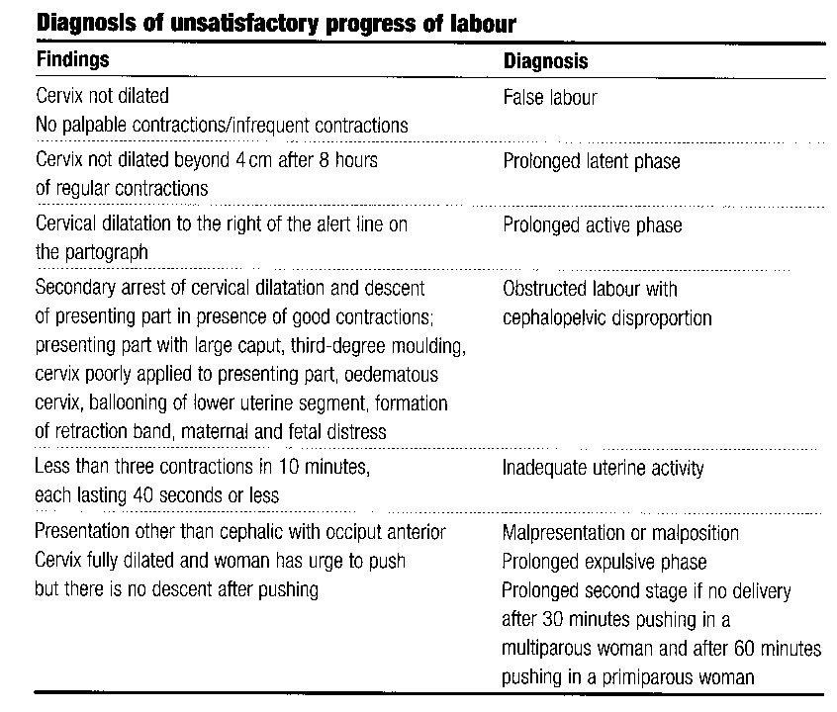

Questions

- What aspects of care in normal labour can be used to improve labour progress?

- What is a complication of obstructed labour for the mother?

- What is a common complication of obstructed labour for the fetus?

PRE-ECLAMPSIA AND ECLAMPSIA
Objectives:
- To recognise pre-eclampsia and eclampsia
- To be able to respond to a woman with pre-eclampsia or eclampsia

Eclampsia accounts for 12% of all maternal deaths in developing countries. It is very important for midwives to be able to detect the onset of early pre-eclampsia, to teach women and their families the symptoms of imminent eclampsia and the need to seek help immediately if these symptoms develop, and to take urgent and appropriate action in cases of severe pre-eclampsia and eclampsia to reduce the risk of maternal death.
Recognising severe pre-eclampsia
Hypertension
- Chronic hypertension is present before 20 weeks gestation.
- Pregnancy-induced-hypertension occurs after 20 weeks gestation, in labour or within 48 hours of delivery. Pregnancy-induced hypertension may progress from a mild hypertension disease to life-threatening eclampsia.
- BP greater than 140/90.
- Diastolic blood pressure is a more reliable indicator of significant hypertension than systolic blood pressure. Diastolic blood pressure is taken at the point at which the arterial sound disappears.
- A falsely high reading is obtained if the cuff does not encircle at least three–fourths of the circumference of the arm; a wider cuff should be used when the diameter of the upper arm is more than 30 cm.
- If the diastolic blood pressure is 90 mmHg or more on two consecutive readings taken four hours or more apart, a diagnosis of hypertension is made. It may be necessary to reduce the time interval to less than four hours in some situations, e.g. in an antenatal clinic or in cases when the diastolic blood pressure is very high, e.g. 110 mmHg or more.

Proteinuria
- Proteinuria 2+ or more is significant.
- Changes the diagnosis from pregnancy-induced hypertension to the more serious condition of pre-eclampsia
- Any woman, however, with both hypertension and proteinuria should be considered to have pre-eclampsia and treated accordingly.
- The urine should always be checked for protein when hypertension is found in pregnancy. The urine for testing should be a clean‑catch, midstream specimen to avoid contamination by vaginal secretions. Dipsticks may be used and a change from negative to positive in pregnancy is a warning sign which should not be ignored.
- Other causes of protein in the urine include urinary tract infection, kidney disease, contamination of the urine specimen, e.g. with vaginal discharge, blood or amniotic fluid, severe anaemia and heart failure.

Symptoms
- Headache
- Blurred vision
- Epigastric pain, upper abdominal pain.
- Hyperreflexia, clonus.
- Jittery.
- Breathlessness
- Reduced urine output
- Reduced fetal growth

Remember
Women with pre-eclampsia do not feel ill until the condition is severe. Then the disease is life threatening. The insidious nature of the disease is one of the reasons why it is so dangerous. Early detection by regular antenatal monitoring and careful follow-up of those with mild pre-eclampsia is therefore essential for the early diagnosis and treatment of severe eclampsia. Sometimes mild pre‑eclampsia progresses to severe pre-eclampsia and eclampsia very suddenly with little or no warning. This is called ulminating pre‑eclampsia and is very dangerous for both mother and fetus.

Eclampsia
- The onset of fits in a woman whose pregnancy is complicated by pre-eclampsia.
- The fits may occur in pregnancy after 20 weeks gestation, in labour, or during the first 48 hours of the postpartum period.
- There is a high incidence of maternal death in women with eclampsia. Perinatal mortality is also high.
- Pre-eclampsia and eclampsia are part of the same disorder with eclampsia being the severe form of the disease. Pre-eclampsia almost always precedes eclampsia. However, not all cases follow an orderly progression from mild to severe disease and some women develop severe pre-eclampsia or eclampsia very suddenly.
- Occasionally convulsions occur when there is no hypertension, only proteinuria. Other women may have raised blood pressure and proteinuria, but only one or two of the signs of severe pre-eclampsia when a fit occurs.

Stages of an eclamptic fit:

1. Premonitory stage:
- This lasts 10–20 seconds
- The eyes roll or stare
- The face and hand muscles may twitch.

2. Tonic stage:
- Lasts up to 30 seconds
- The muscles go into violent spasm
- The fists are clenched and arms and legs are rigid
- The diaphragm (which is a muscle separating the chest from the abdomen) is in spasm, so that breathing stops and the colour of the skin becomes blue or dusky (cyanosis)
- The back may be arched
- The teeth are clenched
- The eyes bulge.

3. Clonic stage:
- Lasts 1–2 minutes
- Violent contraction and relaxation of the muscles
- Increased saliva causes “foaming” at the mouth and there is a risk of inhalation
- Deep, noisy breathing
- The face looks congested (filled with blood) and swollen.

4. Coma stage:
- Lasts for minutes or hours. The woman is deeply unconscious and often breathes noisily. The cyanosis fades but her face may still be swollen and congested. Further fits may occur.
The woman may die after only one or two fits.

Effects on the mother
- The main causes of maternal death in eclampsia are intracerebral haemorrhage, pulmonary complications, kidney failure, liver failure and failure of more than one organ (e.g. heart + liver + kidney).
- Heart failure
- HELLP syndrome (haemolysis, elevated liver enzymes, low platelet count)
- Coagulopathy (clotting/coagulation failure)
- visual disturbances (temporary blindness due to oedema of the retina)
- Injuries during convulsions (fractures).

Effects on the fetus
Pre-eclampsia is associated with a reduction in maternal placental blood flow which results in hypoxia and intrauterine growth retardation (IUGR) in severe cases the baby may be stillborn.
Hypoxia may cause brain damage if severe or prolonged, and can result in physical or mental disability.

Management of pre-eclampsia and eclampsia
- The cure for pre-eclampsia and eclampsia is delivery of the fetus and placenta.
- A rushed delivery in an unstable patient is not advisable. Mode of delivery is decided by a senior obstetrician.
- Only if severe hypertension and hypoxia in the mother have been corrected can delivery be expedited.
- Treat hypertension if systolic BP is 170 mmHg or over or diastolic BP is 110 mmHg or over.
- Aim to reduce BP to 130-140/90-100 mmHg.
- Magnesium sulphate is given if eclampsia seems imminent and/or there is significant hyperreflexia and clonus on clinical examination.
- Magnesium sulphate is given in all cases of eclampsia.

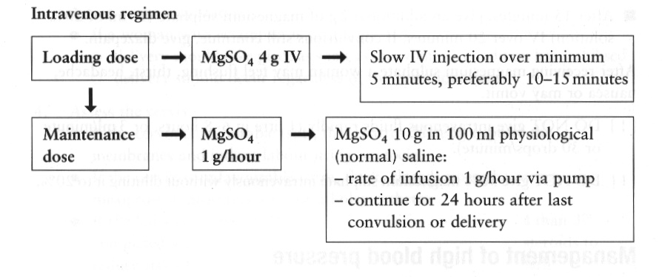
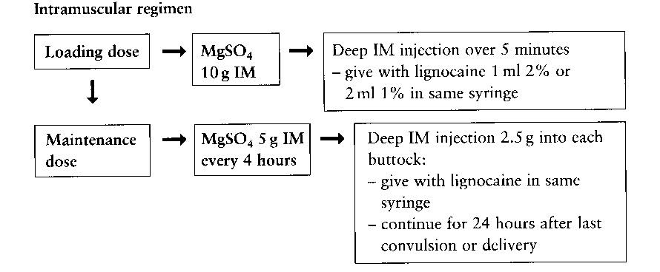

If a woman living in a malarial area has fever, headaches or convulsions and malaria cannot be excluded, it is essential to treat the woman for both malaria and eclampsia.

Magnesium sulphate:
- Is excreted by the kidney. Since eclampsia causes renal impairment it is important to monitor kidney function.
- Monitoring urine output is essential as magnesium becomes toxic if plasma levels are too high.
- Signs of toxicity include: Thirst; warmth; nausea; slurred speech; confusion; absent knee jerk reflexes; reduced urine output; reduced respiratory rate; pulmonary oedema; cardiac arrest.

Questions

1. List five symptoms of severe pre-eclampsia

2. What is the loading dose of magnesium sulphate IM?

3. What are the signs of magnesium toxicity?

4. When do you not give magnesium sulphate?

5. What is the antidote to magnesium sulphate?

OBSTETRIC EMERGENCIES

Objectives:
- To recognise when an obstetric emergency has occurred
- To manage emergencies effectively.
The four most common obstetric emergencies are:
- Prolapsed cord.
- Shoulder dystocia.
- Breech delivery.
- Twin delivery.

Prolapsed cord
The umbilical cord is visible at the vagina or is felt on vaginal examination to be coming down below the presenting part.
Feel the cord gently, check if there are pulsations. If the cord is pulsating, the fetus is alive.
Determine the lie and presentation of the baby: If the baby is in transverse lie, the mother will need a caesarean section.
Cord pulsating: first stage of labour
Take immediate action to stop the presenting part pressing on the cord by:
Asking the mother to adopt the knee-elbow position (see below) or left lateral position with buttocks raised.
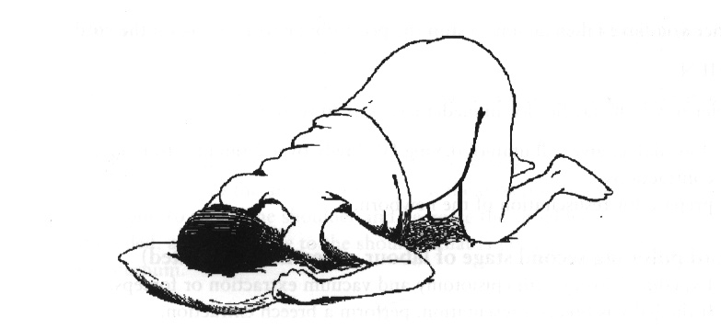
OR manually keeping the presenting part out of the pelvis.
- Wearing sterile gloves insert a hand into the vagina and push the presenting part up to decrease pressure on the cord and dislodge the presenting part from the pelvis.
- Place the other hand on the abdomen in the suprapubic position and keep the presenting part from the pelvis.
- Once the presenting part is firmly held above the pelvic brim, remove the other hand from the vagina. Keep the hand on the abdomen until the time that the caesarean section is performed.
OR Fill the bladder
- Insert a Foleys catheter.
- Fill the bladder through the catheter with 500-750 mls normal saline. Blow up the balloon and clamp the catheter.
- Attach a catheter bag as normal but keep the catheter clamped and fluid in the balloon until baby is delivered.
- At caesarean section release catheter clamp before opening the uterus to empty the balloon.
Cord pulsating, second stage of labour
- Expedite delivery with episiotomy and vacuum extraction.
- If the baby is in the breech position then perform a breech extraction.
- Prepare for resuscitation of the newborn.
Cord not pulsating
- If the cord is not pulsating then the baby has died.
- Check fetal heart by auscultating
- Deliver in a manner that is safest for the woman.

Shoulder Dystocia
Recognising shoulder dystocia
- The fetal head has delivered but the shoulders are stuck and cannot be delivered.
- The fetal head is delivered but remains tightly applied to the vulva.
- The chin retracts and depresses the perineum.
- Traction on the head fails to deliver the shoulder, which is caught behind the symphysis pubis.
Action
- Call for help
- Change labour bed to a half bed or move woman to lie with her buttocks over the side of the bed.
- With the woman on her back, ask her to flex both thighs, bringing her knees as far as possible towards her chest, abduct and rotate legs outwards. (McRobert’s)

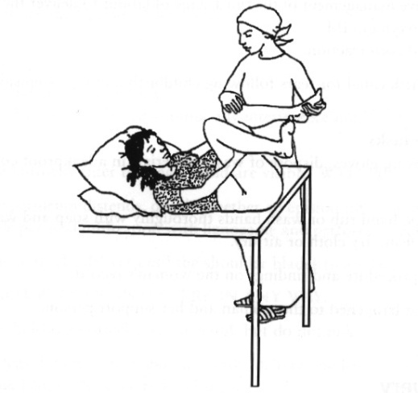

- Apply suprapubic pressure – use the heel of the hands to push shoulder down and under the symphysis pubis from under.
- Do not apply fundal pressure. This will further impact the shoulder and can result in uterine rupture.
- Make an adequate episiotomy to reduce soft tissue obstruction and to allow space for manipulation.
- Apply firm continuous traction downwards on the fetal head to move the shoulder that is anterior under the symphysis pubis. Avoid excessive traction on the head as this may result in brachial plexus injury.
- If the shoulder is still not delivered, insert a hand into the vagina along the baby’s back. Apply pressure to the anterior shoulder in the direction of the baby’s chest to rotate the shoulder and decrease the shoulder diameter. If needed, apply pressure to the shoulder that is posterior in the direction of the sternum.
- If the shoulder still is not delivered, try to deliver the posterior arm. Grasp the humerus of the arm that is posterior and, keeping the arm flexed at the elbow, sweep the arm across the chest. This will provide room for the shoulder that is anterior to move under the symphysis pubis.

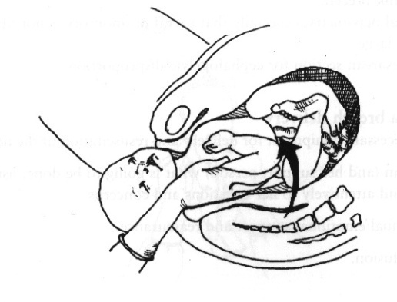

- If all of the above fails, move the woman to an all fours position and repeat manoeuvres.
- A last measure is to break the baby’s clavicle to decrease the width of the shoulders.
- Prepare for resuscitation of the newborn.
- Give oxytocic if available.
- Check for tears and repair episiotomy.
- Let woman know what happened, document.

Breech delivery

Recognising a breech presentation
A breech presentation may be discovered during abdominal palpation of by vaginal examination.

Conditions necessary for breech delivery
- Complete or frank breech.
- Adequate clinical pelvimetry, especially that sacral promontory is not tipped.
- Fetus is not too large.
- No previous caesarean section for cephalopelvic disproportion.

Procedure
- Allow delivery to proceed without any interference until the buttocks are visible.
- As the buttocks enter the vagina and are visible: ensure that the back remains uppermost – remember “bum to tum”.
- As the perineum distends, decide whether an episiotomy is necessary. If needed, provide perineal infiltration with lidocaine and perform an episiotomy.
- Let the buttocks deliver until the shoulder blades are seen.
- Do not pull or interfere in any way.
- Gently hold the buttocks in one hand, but do not pull.
- If the legs do not deliver spontaneously, deliver one leg at a time. Push behind the knee to bend the legs, grasp the ankle and deliver the foot and leg. Repeat for the other leg.
- Hold the newborn by the hips, but do not pull.

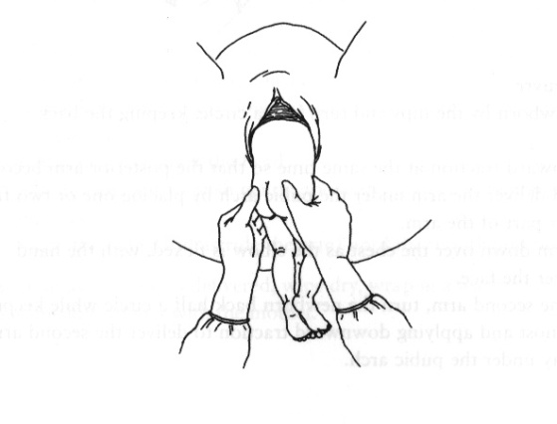
- Ask the mother to continue pushing with contractions.

Delivery of the arms
- If the arms are felt on the chest, allow them to disengage spontaneously one by one. After spontaneous delivery of the first arm, lift the buttocks toward the mother’s abdomen to enable the second arm to deliver spontaneously.
- If the arm does not deliver spontaneously place one or two fingers in the elbow and bend the arm, bringing the hand down over the newborn’s face.
- If the arms are stretched above the head or folded around the neck, use Lovsets manoeuvre:

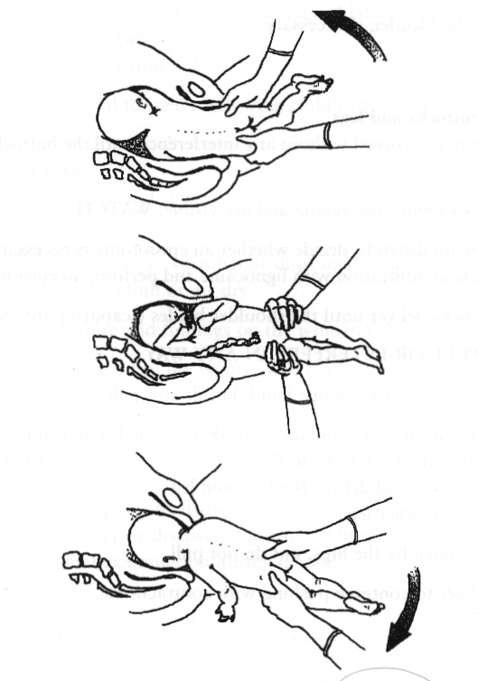

Lovsets manoeuvre
- Hold the newborn by the hips and turn half a circle, keeping the back uppermost.
- Apply downward traction at the same time so that the posterior arm becomes anterior and deliver the arm under the pubic arch by placing one or two fingers on the upper part of the arm.
- Draw the arm down over the chest as the elbow is flexed, with the hand sweeping over the face.
- To deliver the second arm, turn the newborn back half a circle while keeping the back uppermost and applying downward traction to deliver the second arm in the same way under the pubic arch.
- If the newborn’s body cannot be turned to deliver the arm that is anterior first, deliver the arm that is posterior.

Delivery of the head
- After the arms are delivered, allow the head to descend until the hairline is visible, then deliver the head by the Mauriceau-Smellie-Veit manoeuvre.
- Lay baby face down with the length of its body over your hand and arm.
- Place first and third fingers of this hand on the baby’s cheekbones.
- Use the other hand to grasp the newborn’s shoulders.
- With two fingers of this hand, gently flex the baby’s head toward the chest to encourage flexion of the head.
- At the same time apply downward pressure on the jaw to bring the baby’s head down.
- Pull gently to deliver the head.
- Raise the baby (still astride the arm) until the mouth and nose are free.

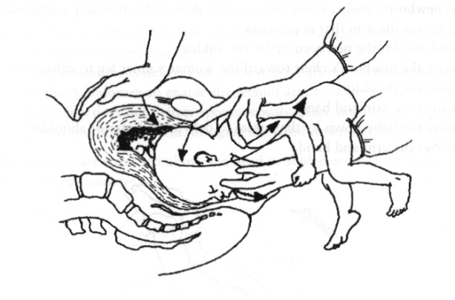

- Prepare for resuscitation of the newborn.
- Give oxytocic if available.
- Check for tears and repair episiotomy.
- Let woman know what happened, document.

Footling breech
A footling breech should usually be delivered by caesarean section unless:
- Labour is well advanced and the cervix is fully dilated.
- Preterm baby that is not likely to survive.
- You are delivering a second baby (of twins or triplets).

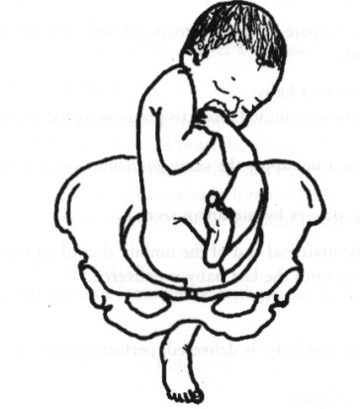

Twin delivery
Recognising a twin presentation
A breech presentation may be discovered during abdominal palpation or by vaginal examination.

First baby
- If a vertex presentation, allow labour to progress as for a single vertex presentation, use partograph.
- If a breech presentation, apply the same guidelines as for a single breech presentation.
- If a transverse lie, deliver by caesarean section.
- Leave the clamp on the maternal end of the umbilical cord and do not attempt to deliver the placenta until the last baby is delivered.
Second baby
- Immediately after the first baby has delivered, perform a vaginal examination to determine if the cord has prolapsed and, whether the membranes are intact or ruptured. Determine the presentation of the baby.
- If possible correct to longitudinal lie.
Vertex presentation
- If membranes are intact, carry out a controlled rupture of membranes and facilitate descent of head into pelvis.
- If contractions are inadequate, consider augmenting labour.
- If delivery does not occur within 2 hours of good contractions, deliver by assisted delivery or caesarean section.
Breech presentation
- If the baby is considered to be no larger than the first and the cervix has not contracted, prepare for breech delivery.
- If contractions are inadequate consider augmenting labour.
- If the membranes are intact, rupture them once the breech has descended.
- If vaginal delivery is not possible, move to caesarean section.
- Prepare for resuscitation of the newborn.
- Give oxytocic if available.
- Check for tears and repair episiotomy.
- Let woman know what happened. Document.

Questions

- What are the risk factors for prolapsed cord?

- What is the main idea behind managing cord prolapsed?

- What are the three ways of achieving this?

- Why will performing an episiotomy not resolve a shoulder dystocia?

- Why will fundal pressure not resolve a shoulder dystocia?

- What is the aim when faced with a shoulder dystocia?

- How do we achieve this?

- When delivering a breech presentation why is “bum to tum” so important?

- Why should footling breeches be delivered by caesarean section?

SEPSIS
Objectives:
- To learn to recognise sepsis
- To practise an effective response to a woman with sepsis

Puerperal sepsis is one of the major causes of maternal death and accounts for 15 per cent of all maternal deaths in developing countries. If it does not cause death, puerperal sepsis can cause long-term health problems such as chronic pelvic inflammatory disease (PID) and infertility.
It is extremely important for midwives to be able to prevent puerperal sepsis and treat it promptly.
Puerperal sepsis is any bacterial infection of the genital tract which occurs after the birth of a baby. It is usually more than 24 hours after delivery before the symptoms and signs appear. If, however, the woman has had prolonged rupture of membranes or a prolonged labour without prophylactic antibiotics, then the disease may become evident earlier.

Recognising sepsis:
- Fever – temperature of 38 ⁰ C or above.
- Chills or rigors.
- Lower abdominal pain.
- Tender uterus.
- Sub-involution of uterus.
- Foul smelling lochia.
- Warm extremities.
- High respiration rate.
- Increased pulse rate.
- Low blood pressure

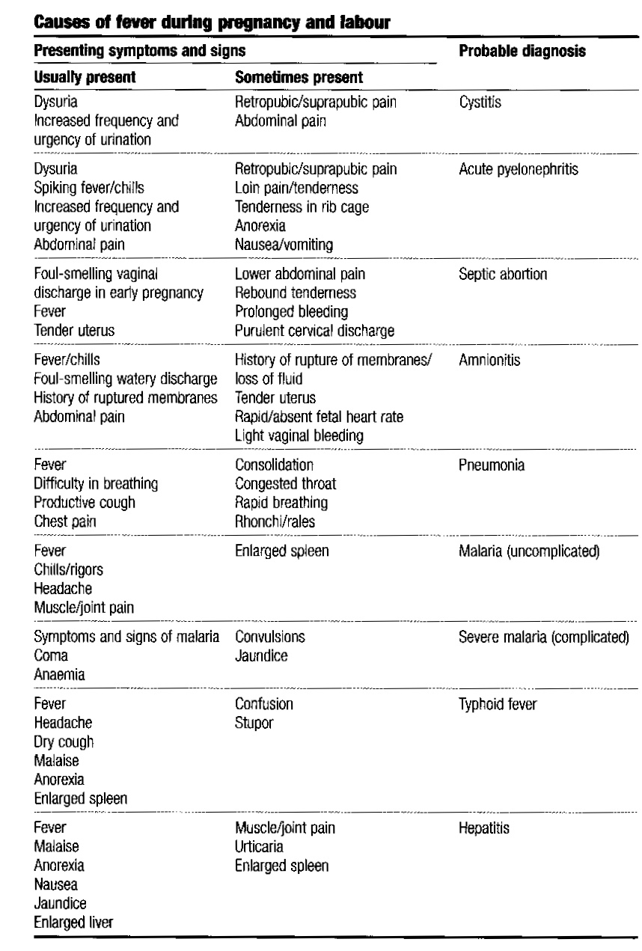

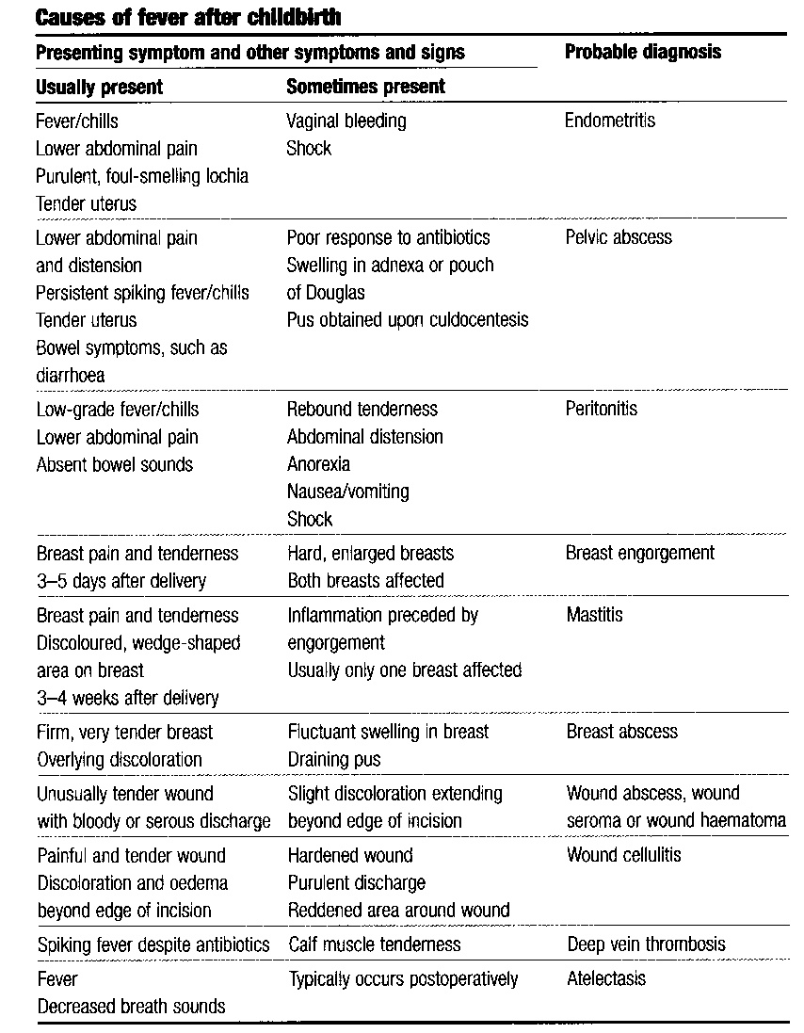

Risk factors:
- poor standards of hygiene
- poor aseptic technique
- manipulations high in the birth canal
- presence of dead tissue in the birth canal (due to prolonged retention of dead fetus, retained fragments of placenta or membranes, shedding of dead tissue from vaginal wall following obstructed labour)
- insertion of unclean hand or non-sterile instrument, packing into the birth canal
- pre-existing anaemia and malnutrition
- prolonged/obstructed labour
- prolonged rupture of membranes
- frequent vaginal examinations
- caesarean section and other operative deliveries
- unrepaired cervical lacerations, or large vaginal lacerations
- pre-existing sexually transmitted infections
- postpartum haemorrhage
- diabetes

Management:
- Start IV and if the woman is conscious, encourage increased fluids by mouth.
- Use a fan and or tepid sponging to help decrease temperature.
- If shock is suspected, begin antibiotic and antimalarial treatment at once.
- Treat the cause.

Mastitis
- Treat with antibiotics.
- Continue breastfeeding.
- Support breasts with bra or binder.
- Apply cold compresses to breasts between feeds to reduce swelling and pain.
- Give breastfeeding support to ensure good positioning and attachment.
- A breast abscess will need to be seen by a doctor.

Scenario One
Woman A had a long labour with many vaginal examinations.
Her membranes had been ruptured for over two days before the baby was born.
She had a deep tear to her vaginal wall that was not sutured.
Now she finds that her lochia smells bad, she does not feel well. She has lower abdominal pain and a temperature of 38.

What is happening?

How can we confirm this?

What can be done?

Scenario 2
Woman B had her baby three weeks ago. She has been breastfeeding but the baby has not been fixing well.
Now one breast feels full, there is a red area above the nipple that is painful to touch.

What is happening?

How can we confirm this?

What can be done?

Scenario 3
Woman C had her baby a week ago. She had a small tear that was not sutured. The tear was uncomfortable when she passed urine and so she was not passing urine very often.
Now she has to pass urine frequently and it is extremely painful. She has a fever and has been vomiting for the last day.

What is happening?

How can we confirm this?

What can be done?

Infection control

Isolation and barrier midwifery care
The aim of this is to prevent the spread of infection to other women and their babies.

Basic principles of care are important. The midwife should:
- Care for the woman in a separate room or, if that is not possible, in the corner of the ward, separated from the other women.
- Wear a gown and gloves when attending to the woman and remove the gown and gloves on completion of her care; these garments must not be used when attending to other women.
- Wash hands carefully before and after attending to this woman.
- Keep one set of equipment, dishes and other utensils exclusively for the use of this woman and make sure they are not used by anyone else.
- Ensure that soiled dressings are disposed of carefully, e.g. placed in a separate container which is emptied regularly and the dressings incinerated.
- Ensure that soiled linen is placed in a bag which is specifically marked for transport to the laundry, where it will be specially treated.

Where possible, a midwife/nurse should be allocated to care specifically for this mother and her baby. It may also be helpful to have a relative assist with their care. If so, the relative must be instructed in the basic principles of preventing the spread of infection. Visitors should be limited.

Hand washing is important to reduce the spread of infection because the mechanical friction of washing with soap and water removes many of the pathogens responsible for disease transmission. Running water should be used rather than bowls of water (if piped water is not available, a clean, refillable container with a tap attached should be used). Either plain or antiseptic soapcan be used. A clean towel should be used for drying hands. Do not use shared towels.
Hands should be washed at the following times:
- Before performing a physical or pelvic examination or other procedure.
- Before putting on gloves.
- After handling used (soiled) instruments.
- After touching mucous membranes, tissue, blood or other body fluids.
- After taking off gloves.
- Between contact with different patients.

Glove use

New gloves or gloves that have been high-level disinfected should be worn by health care workers when performing pelvic examinations and other procedures, especially when the hands might be exposed to blood or body fluids. Gloves must be changed between patients and between procedures.
Health care workers who clean or handle used instruments and who have the potential for contact with blood should wear gloves when cleaning up after a procedure, disposing of waste or processing soiled linen. Thick utility gloves are preferable for these activities.
Gloves must be intact (i.e. must be free from holes, tears, cracks, peeling).
They should be checked before use and any that have holes, tears, cracks or are peeling should be discarded.

Apron, gown and goggle use

Plastic or rubber aprons should be worn for protection during procedures where splashing of blood or other body fluids is anticipated. During surgical procedures, where there is a high likelihood of splashing of blood, a fluid-repellent gown or a sterile cloth gown with a plastic apron underneath should be worn.

Handling and disposal of “sharps”

Needles or “sharps” should be handled carefully during use and placed in a puncture-proof container immediately after use and should preferably be incinerated.
The greatest hazard of HIV transmission in health care settings is through skin puncture with contaminated needles or “sharps”. Most “sharps” injuries involving HIV transmission are through deep injuries with hollow-bore needles.

Such injuries frequently occur when needles are recapped, cleaned, or disposed of inappropriately.

Puncture-resistant disposal containers must be available and readily accessible (i.e. at the point of use) for the disposal of “sharps”. Many easily available containers such as a tin with a lid, a thick plastic bottle with a lid, or a heavy plastic or cardboard box with a small opening in the top can be used as “sharps” containers. It is important to dispose of containers when they are three-quarters full, and to wear heavy-duty gloves when transporting “sharps” containers to the incinerator.

Postpartum Haemorrhage (PPH)
Objectives:
- To define pph, primary pph and secondary pph.
- To recognise pph and understand its causes.
- To understand risk factors for pph.
- To understand appropriate management of pph.

Postpartum haemorrhage (PPH) is the most common cause of maternal death in the developing world, accounting for twenty-five per cent of all maternal deaths. This figure refers to cases in which PPH was the direct cause of maternal death. But PPH is often an associated complication in other direct causes such as obstructed labour and sepsis.
It is very important for midwives to be able to prevent PPH, where possible, and manage it promptly if it occurs.
A good understanding of the physiology and management of the third stage of labour helps to promote good practice.
Postpartum Haemorrhage:
A loss of 500 ml or more from the genital tract after delivery.

Primary postpartum haemorrhage:
Excessive bleeding occurring within 24 hours of delivery.

Secondary postpartum haemorrhage:
Excessive bleeding occurring between 24 hours after delivery of the baby and 6 weeks postpartum.

Causes of PPH: The 4 T’s

- TONE Atonic uterus- uterus is not able to contract well for a number of different reasons.
- TISSUE Placental tissue, membranes or blood clots that remain in the uterus and prevent it from contracting.
- TRAUMA Tears to the vaginal wall, perineum, cervix or uterine wall from which blood is lost.
- THROMBIN Clotting disorders. If the woman has lost all the clotting factors in her blood due to excessive pph.

Risk factors for PPH:

TONE
- Full bladder.
- High parity (uterus loses elasticity).
- Multiple pregnancies.
- Polyhydramnios.
- Large baby.
- Fibroids (health check between pregnancies, management when diagnosed and family planning in older women).
- Tired uterus.
- Prolonged labour (avoid by correct use of the partograph and timely referral for assessment and, if no contraindication, augmentation of labour, or operative delivery, if indicated).
- Mismanagement of third stage labour.
- Placental abruption (muscle fibres are damaged due to concealed uterine haemorrhage).

TISSUE
- Retained placenta
- Retained placental tissue or membrane
- Incomplete separation of placenta
- Mismanagement of third stage labour

THROMBIN
- Coagulopathy
- Previous third stage complication (previous retained placenta, previous PPH)
- Severe pre-eclampsia and eclampsia

Recognising primary PPH:
Bleeding with a pad or cloth soaked in less than 5 minutes or constant trickling of blood or bleeding more than 500mls.

When there is vaginal bleeding:
- up to 150 ml is a normal loss
- 300 ml is a heavy loss
- 500 ml is a postpartum haemorrhage
- any amount of blood loss is a PPH if the woman’s condition deteriorates (may occur especially when the woman is anaemic).

Research has shown that blood loss is frequently underestimated and therefore careful observation and measurement ofblood loss is important.

It is very important to identify the causes of bleeding correctly since this will determine the management. Is the bleeding atonic or traumatic? It is essential to find out why the woman is bleeding.

Atonic bleeding is bleeding from theplacental site due to inability of the uterus to contract adequately.

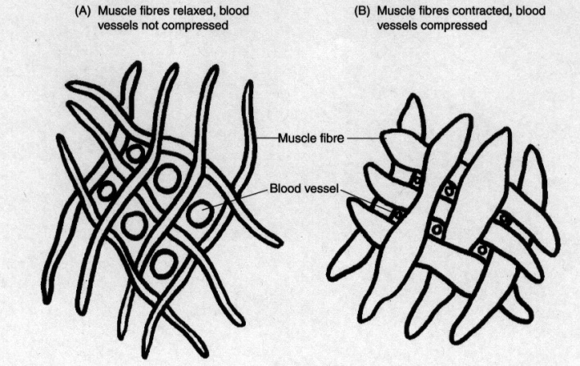
Action of the uterine muscle fibres in the control of postpartum bleeding from the placental site

If the bleeding is atonic it is important to find out if the placenta has been delivered or not. When the third stage is managed actively, the placenta is normally delivered within 5–10 minutes of birth of the baby. It takes longer to separate and deliver during physiological management, 20–30 minutes. If the placenta has been delivered, ask if it appears complete.
A quick examination of the placenta at the bedside will establish if there is part of the placenta missing. Remember that a tiny part of placental tissue retained in the uterus can cause severe haemorrhage.

Traumatic bleeding is bleeding due to trauma or injury of the genitaltract.
Bleeding is traumatic when there is vaginal bleeding and the uterus is well contracted.

It is important to find out where the bleeding point is:
- Perineum - tear or episiotomy wound.
- Vulva - ruptured varicosities, tears or haematoma can occur (haematoma may not be obvious immediately after delivery, but can cause severe pain and shock).
- Vagina - lacerations of the walls or rupture of varicosities.
- Cervix - lacerations can occur.
- Uterus - rupture or inversion of the uterus can also occur and are accompanied by marked pain and shock.
The bleeding point may or may not be visible.
It is possible to quickly find the bleeding point if the bleeding is from the perineum, vulva or lower vagina.
If the bleeding point is not easily visible, it will be necessary to insert a speculum to observe the upper vagina and cervix.

If the woman is showing signs of severe shock, consider ruptured uterus.

Coagulopathy

Blood normally clots within approximately 5 minutes. If it fails to clot within 7 minutes, there is a clotting defect. Clotting failure is both a cause and a result of massive obstetric haemorrhage. It can be triggered by placental abruption, intrauterine fetal death, septic shock, severe pre-eclampsia and eclampsia, amniotic fluid embolism and other causes. Coagulopathy should be suspected when there is delay in clotting time and a woman with one of the above conditions suddenly starts bleeding from multiple sites (e.g. vagina,nose, gums, and skin).

In many cases of very heavy blood loss, the development of coagulopathy can be prevented if blood volume is restored promptly by infusion of IV fluids, either normal saline or Ringer’s lactate.

Treatment of clotting failure includes treating the cause ofcoagulopathy, and giving a blood transfusion to replace clotting factors and red cells

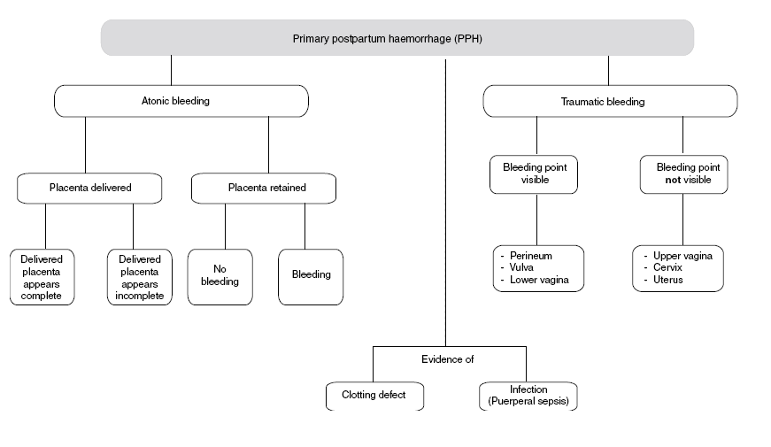

Recognising secondary PPH:

- Retained products (membranes or placental tissue)
- Shedding of dead tissue following obstructed labour (this may involve cervix, vagina, bladder or rectum)
- Infection. Suspect puerperal sepsis if the woman has fever, lower abdominal pain, purulent, foul smelling lochia and a tender uterus. She may also develop septic shock.
- Breakdown of the uterine wound after caesarean section or ruptured uterus.

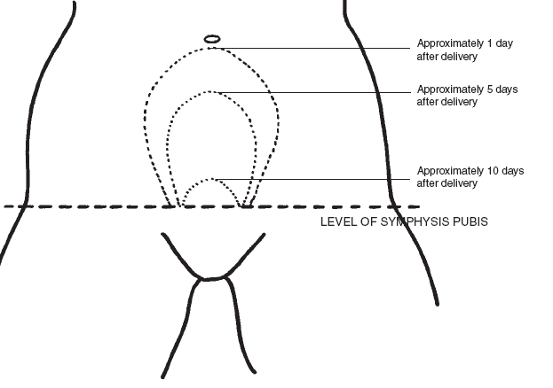

Normal postpartum involution of the uterus

Management of PPH:
- Call for help
- Establish the cause of bleeding.
- Check and record BP and pulse every 15 minutes.

Bleeding with placenta not delivered or delivered incomplete
- Give oxytocic drug.
- Massage the uterus until it is hard.
- Empty bladder, catheterise if necessary.
- Give IV fluids.
- Deliver placenta and membranes using controlled cord traction.
- If unsuccessful and bleeding continues, remove placenta manually and check it carefully.
Bleeding with placenta delivered complete
- Give oxytocic drug.
- Massage the uterus until it is hard.
- Empty bladder, catheterise if necessary.
- Continue to bimanual compression of the uterus if necessary. (see below)

Perineal and vaginal tears
- Examine the tear and determine the degree and extent of the tear. A third or fourth degree tear will require appropriate hospital repair.
- Apply pressure over the tear with a sterile pad or gauze and put legs together. Do not cross ankles.
- If bleeding persists repair the tear.
Bimanual compression of the uterus
- Explain to the woman quickly what needs to be done. Listen to her and respond attentively to her questions and concerns.
- Provide continual emotional support and reassurance as feasible.
- Put on personal protective equipment.
- Wash hands thoroughly with antiseptic hand rub or soap and water. Dry with a sterile cloth.
- Put on sterile gloves.
- Clean the vulva and perineum with antiseptic solution.
- Insert one hand into the vagina and form a fist.
- Place the fist into the anterior vaginal fornix and apply pressure against the anterior wall of the uterus.
- Place the other hand on the abdomen behind the uterus.
- Press the abdominal hand deeply into the abdomen and apply pressure against the posterior wall of the uterus.
- Maintain pressure until bleeding is controlled and the uterus contracts.
- Wash hands thoroughly with antiseptic hand rub or soap and water. Dry with a sterile cloth.
- Monitor vaginal bleeding and take the woman’s vital signs every 15 minutes for 1 hour then every 30 minutes for 2 hours.
- Make sure that the uterus is well contracted.

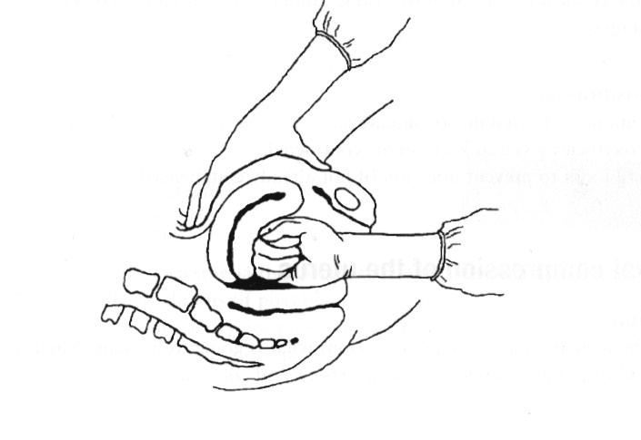 Bimanual compression of the uterus

Misoprostol:
- Prostaglandin.
- Effects seen within 10 minutes.
- Peak uterine activity seen 5-7 hours later.
- In case of PPH it is best to administer PR.
- Can be administered orally as prophylaxis.
- Acts on smooth muscle – causes uterus to contract.
- Can cause diarrhoea, vomiting, and abdominal cramps.

Questions

1. How much blood can a woman lose in one minute?

2. What is the blood volume of a pregnant woman?

3. How quickly could a pregnant woman lose her entire blood volume?

4. How much blood can a healthy pregnant woman lose before she becomes symptomatic?

5. Why does anaemia have an impact on PPH?

CARE OF THE NEWBORN
Objectives:
- To understand and to be able to demonstrate safe resuscitation of the newborn.

Initial care of the newborn
- Dry the baby, wiping off any meconium or blood.
- Check the baby’s breathing and colour every 5 minutes.
- Ensure baby is covered with clean dry cloths and keep with mother if able. If the baby’s temperature is below 36.5 ⁰ C, re-warm the baby.
- Check the cord for bleeding every 15 minutes. If the cord is bleeding, retie the cord more tightly.
- Encourage breastfeeding within the first hour of birth.
Resuscitation and care of the newborn
- Hands should be washed and gloves worn before touching the newborn.
- Tell the woman (and her support person) what is going to be done, listen to her and respond attentively to her questions and concerns.
- Provide continual emotional support and reassurance as feasible

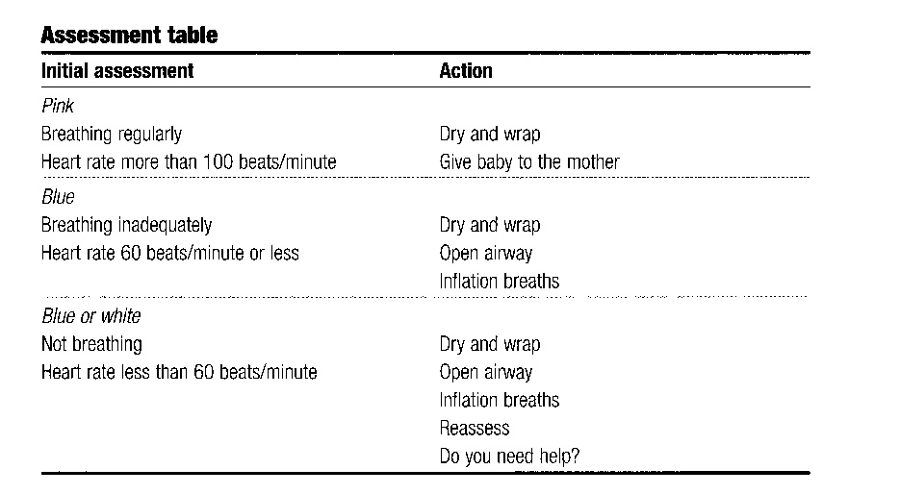

Start resuscitation within one minute of birth if the baby is not breathing or is gasping for breath. Initially, an assessment of heart rate is made, by listening with a stethoscope at the apex of the heart or feeling the chest. This is done because heart rate is used to assess the effectiveness or otherwise of the resuscitation process to follow. Once the baby has a patent airway it is very likely to resuscitate spontaneously.
- Call for help.
- Check the time.
- Dry the baby, wrap in a fresh towel and keep warm.
- Asses initially by listening with a stethoscope at the apex.
Note: the heart rate is a guide to the success of resuscitation.
The Apgar score is then calculated at 1 and 5 minutes and is a tool for evaluating baby’s condition at birth. It is not used to guide resuscitation. It assesses:
- BREATHING: rate and quality (airway and breathing)
- HEART RATE: fast, slow, absent
- COLOUR: pink, blue, pale (circulation)
- TONE: unconscious, apnoeic babies are floppy

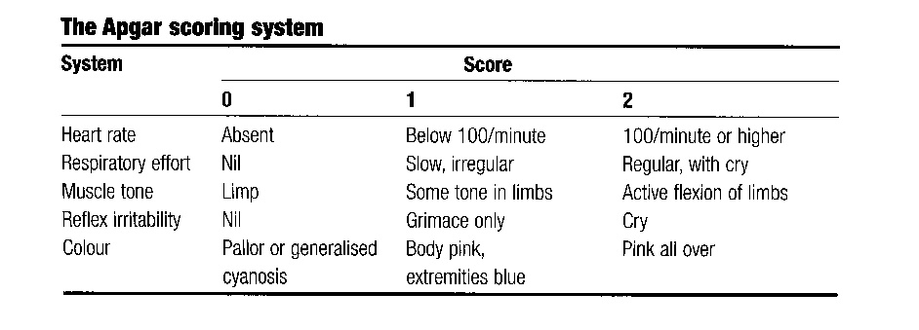

Airway:
- Position the head in the neutral position to open the airway. Over extension or flexion will collapse the pharyngeal airway. A towel folded to 2-3 cms thickness placed under the shoulders will help to achieve the correct position.
- Most babies, even those born not breathing, will resuscitate themselves given a clear airway.
- If the baby is floppy, use the jaw thrust to bring the tongue forward and open the airway. Very gentle suction of the oropharynx or nostril only using a soft suction catheter may be used. Deep suction is dangerous and should not be used – it can cause bradychardia and spasm of the larynx.
- In the unconscious baby, airway obstruction is usually due to loss of pharyngeal muscle tone and to foreign matter in the airway. Simply opening the airway will solve the problem.
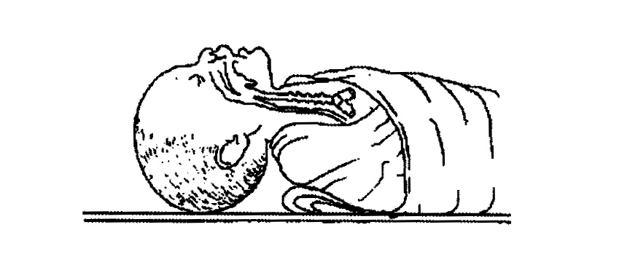
Breathing:
If the baby does not respond to opening the airway as described above:
- Place the mask (attached to the bag) firmly over the newborn’s mouth, chin and nose, to from a seal between the mask and the newborn’s face.
- Using bag and mask, give five inflation breaths, each of 2-3 seconds.
- Check the rise of the chest. The chest may not move during the first one to three inflation breaths, which are needed to displace fluid from the lungs.
- Check the seal and that the chest rises and falls with inflation breaths after that.
- Reassess the heart rate after the first five breaths: an increasing heart rate or a heart rate maintained at more than 100 bpms is a sign of adequate ventilation. If the heart rate has not responded check again for chest movements and check for patent airway when attempting to deliver ventilations.
- Ventilations should be continued at 30-40 breaths/minute.
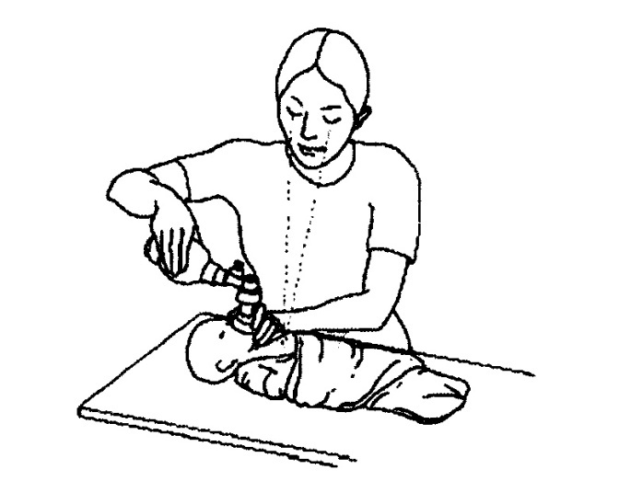

Circulation:
If there is no heartbeat or the heartbeat is less than 60 bpms, even when the chest is being ventilated, give chest compressions. However, the most common reason for the heart rate remaining low is that successful ventilation has not been achieved.

Chest compressions:
- The best way to give cardiac massage is to encircle the baby’s chest with two hands so that the thumbs meet on the sternum below the line between the nipples (see below). Compress chest by 1/3 of its depth – three times for each ventilation.
- Once the heart rate is above 60 bpms and rising, chest compressions can be discontinued.
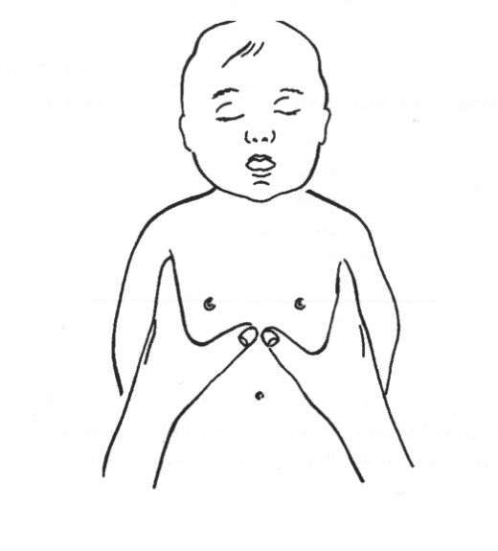
If the baby’s breathing is normal (30-60 breaths/minute) and there is no indrawing of the chest and no grunting:
- Put in skin-to-skin contact with the mother
- Observe breathing at regular intervals. Observe the baby for at least 6 hours.
- Measure the newborns temperature and re-warm if less than 36.
- Encourage mother to start breastfeeding.
- Explain what happened to the mother.
- Document what happened.
If there is no gasping or breathing at all after 20 minutes of ventilation, or gasping but no breathing after 30 minutes of ventilation, stop ventilating. Provide emotional support to the family
Do not in any case:
× Slap, blow on, or pour cold water on the baby.
× Hold the baby upside down.
× Use heavy suctioning at the back of the throat of the baby.
× Give injections of respiratory stimulants or routine sodium bicarbonate injections.

Questions:
Q. Which five things doesthe APGAR score asses?

Q. Why is it important to keep the baby warm?

Q. Why are inflation breaths important?

Q. How long should each inflation breath last?

Q. At what rate are ventilation breaths given?

Q. If the heart rate does not increase after giving inflation breaths what is the most
important thing to do?

Q. At what rate are chest compressions given?

Answers
Normal labour
1.

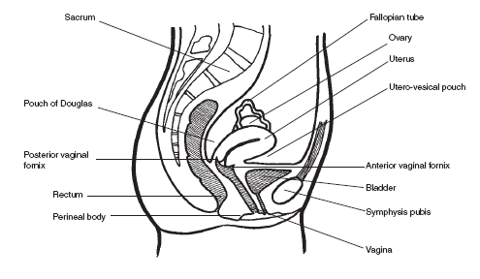

2. Ensures that the bladder can adequately contract and allows for descent.
3. To ensure a controlled delivery, allow for perineal stretching and minimise tearing.
4. If the placenta is not separated, then uterine inversion can occur.

Obstructed labour

1. Bladder care; mobilising; eating and drinking; relaxation.
2. Vesico-vaginal fistula. Prolonged compression of tissue causes necrosis of the bladder and vaginal wall. This breakdown of tissue creates the fistula.
3. Infection.

Pre-eclampsia and eclampsia
1. BP >140/90
proteinuria> +2
headache
blurred vision
epigastric pain
hyperreflexia and clonus.
2. 10g.
3. Thirst; warmth; nausea; slurred speech; confusion; absent knee jerk reflexes; reduced urine output; reduced respiratory rate; pulmonary oedema; cardiac arrest.
4. If the woman does not need it; if knee jerk reflex is absent; if urine output is < 100mls over 4 hours; if respiratory rate is less than 16/minute.
5. Calcium gluconate.

Obstetric emergencies
1. Polyhydramnios
twins
head high in the pelvis
malpresentaion

2. To prevent the presenting part from occluding the cord.
3. Relieving pressure by changing maternal position
Relieving pressure manually
Filling the bladder to lift the presenting part off the cord.
4. The shoulder is behind bone not the perineum.
5. Fundal pressure will further impact the shoulder.
6. The aim is to dislodge the shoulder from behind the symphysis pubis.
7. Increase the outlet of the pelvis (McRoberts or all fours position).
Manually move the shoulder.
Reduce the presenting diameter by removing the posterior arm.
8. If the baby is not held like this it will not fit through the pelvis.
9. A foot will come through a partially dilated cervix, the rest of the baby will not be able to.

Sepsis
Scenario 1
- Puerperal sepsis.
- High vaginal swab, blood cultures.
- She needs antibiotics, IV fluids and close monitoring.
Scenario 2
- Mastitis
- Culture of breast milk.
- She needs antibiotics and breastfeeding support.
Scenario 3
- Bladder/kidney infection.
- Culture of urine, blood cultures.
- Antibiotics, IV fluids, close monitoring.

Postpartum haemorrhage

1. Up to 500 mls/minute.
2. 5 – 6 litres.
3. 10 minutes.
4. 30% of her volume.
5. Anaemic women will lose less blood before they become symptomatic. They can afford to lose less blood than healthy women.

Care of the newborn
1. Colour
Tone
Respiratory effort
Heart rate
Response to stimulation.
2. Babies lose a lot of heat as they have a relatively large surface area and are born wet. A cold, wet baby will use most if its energy reserves trying to keep warm.
3. At birth the lungs are filled with fluids, inflation breaths ensure that the lungs are filled with air.
4. 2-3 seconds.
5. 30-40 per minute.
6. Ensure that the lungs were adequately inflated – make sure you see the chest rise with inflation breaths.
7. 3 chest compressions to one ventilation breath.

